FARMER
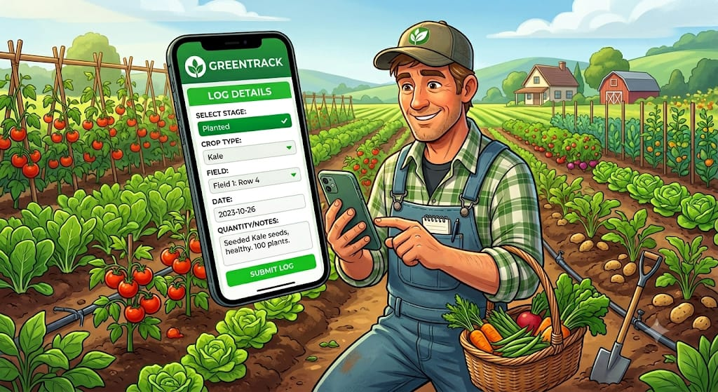
Mwangi is a farmer who uses the Greentrack app to track the progress of the crops in his garden.
Whenever he plants crops in his garden, he creates a new crop batch, inputs the crop name, selects his farming method and uses his GPS location to pin drop the exact location of his plot all on the “Greentrack” app.
To grow nutrient-rich vegetables, he manages a strict watering schedule. Using the app, he logs into the irrigation system with just a single tap and he is able to record the source of his water, the time he irrigated his crops and this way he is able to know the appropriate time for his next irrigation and the appropriate amount of water for each crop, all scheduled in the app.
Weather conditions is another key factor to be considered in the farming process. With Greentrack, Mwangi will no longer have to follow the traditional farming patterns passed down through generations. He will be able to know the seasons for long rains and short rains and how much water his crops need in certain conditions and the appropriate seasons to plant certain crops.
In a case where he notices pests on his crops, instead of panicking, he navigates to the Pest diagnosis module on Greentrack. He takes a photo of the affected leaves and the app’s integrated database matches the visual symptoms and confirms the type of pests on his crops and the appropriate pesticide and how to spray it.
When harvest time approaches, the app enforces a Pre-harvest Interval (PHI) based on the pesticide control step. The app locks the harvest function for the crop batch. Mwangi must wait out the countdown to guarantee that any spray residue has completely broken down, making the produce safe for consumption.
1-2 days before the harvest, Mwangi inspects his plot to check for maturity and estimate how many kilograms or crates will be yielded then inputs that data on the app. This alerts partnered
buyers that a fresh batch of a specific size is about to be available, preventing food waste from sitting around after being picked.
When harvesting, the farmer taps “Log Harvest” in the app, which automatically captures the exact date, time and ambient weather conditions. All historical data as from is then aggregated.
After harvest, Mwangi will input the final verified weight on the app , which will then instantly process all the logs and auto-generate unique QR code for that specific batch. Mwangi will then print the QR code and stick it directly onto the delivery crates or packages.
Mwangi can now deliver his harvest to his buyers as he now plans to plant new crops again and repeat the same cycle using the Greentrack app.

GROCERY SHOPPER
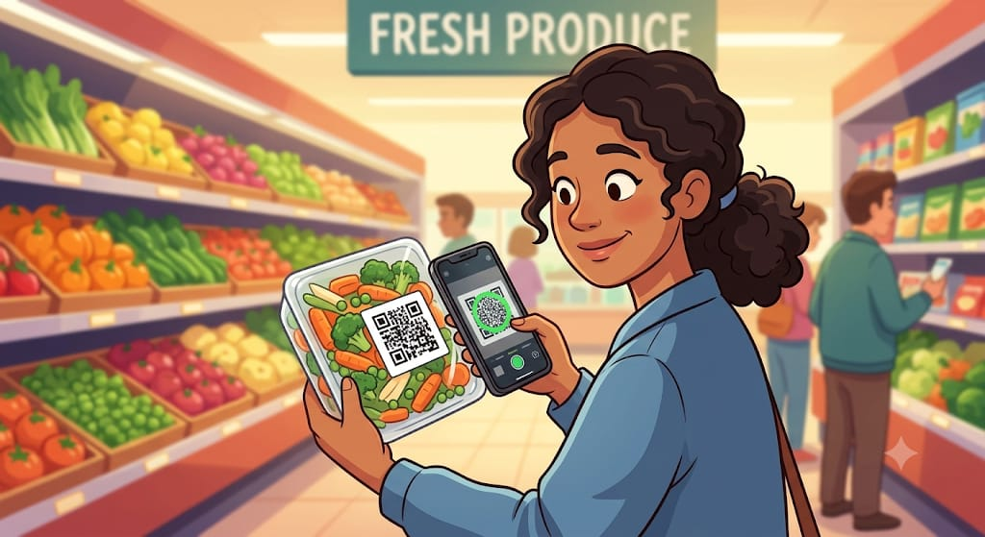
Meet Faith, a busy shopper who cares deeply about organic, fresh food but she is skeptical about supermarket labels and wants to know exactly where her vegetables are sourced.
Faith stands in the grocery aisle looking at a package of vegetables labelled “fresh” but she has no way of verifying if it was harvested yesterday locally or it travelled for days on a truck.
She pulls out her phone, opens the “Greentrack” app and scans the QR code on the packaging. Instantly, she sees the exact farm it was harvested and the journey the vegetables followed to the grocery store shelf.
She adds the vegetables to her shopping cart with confidence.

CHEF
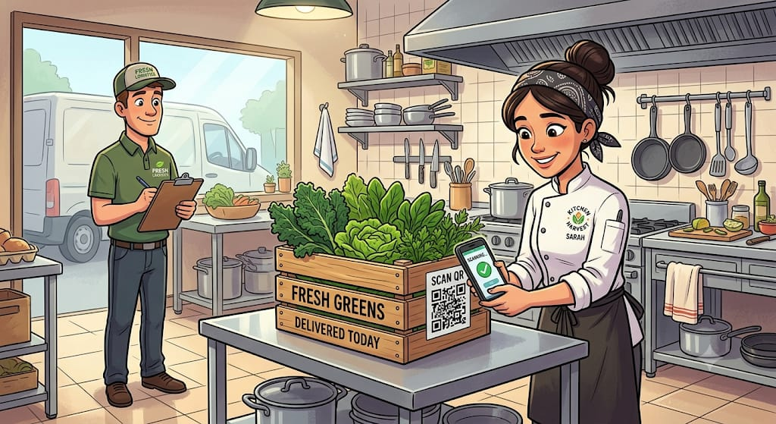
Sarah is a chef in a restaurant that is well known for their “green bowl” (a vegetables dish). She has just received a crate of vegetables from a supplier but she wants to ensure that they are fresh and locally sourced. Through Greentrack, she will not have to trust the supplier’s word for it and risk serving a dull day-old produce that loses it nutritional value the longer it sits in transit, but she will instead verify the vegetables freshness on the app. She will be able to scan the QR code on the crates and instantly confirm the greens were harvested by Mwangi just hours ago and lists their organic certification. Confident in their freshness and maximum nutrient retention, she builds her signature green bowl for the lunch rush, proud to know exactly what is entering her kitchen.

DINER
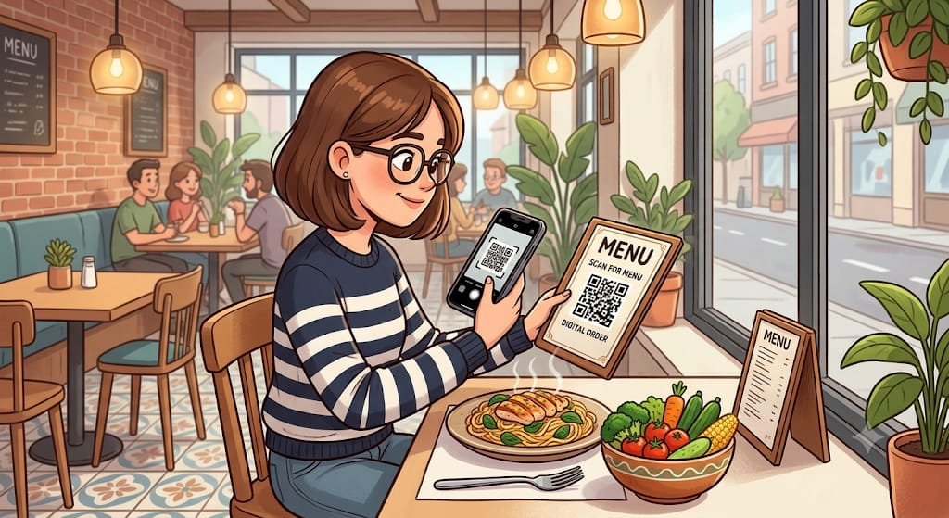
Mary, a fitness-oriented lady, sits at chef Sarah’s reataurant looking at the menu. The description says “Nutrient-rich organic green bowl” but she is skeptical. Restaurant meals are notoriously hard to track accurately; she doesn’t know exactly the nutritional density or if the ingredients are truly fresh enough to retain their vitamins.
When her meal arrives, she notices a small Greentrack QR code printed next to the menu. She scans it with her phone. Instantly, her screen populates with a beautiful breakdown of the exact vitamin and caloric content of the meal, verified by the fresh transit timeline.
She logs the exact nutrients into her fitness tracker with absolute peace of mind and she enjoys a meal she completely trusts.

